Practice Questions

***Question 1***

Create a Finite automata of the following game of snakes and ladders, the input will be from a number between 1 and 6.

Clearly define, States, Final States, Initial State and Transitions.

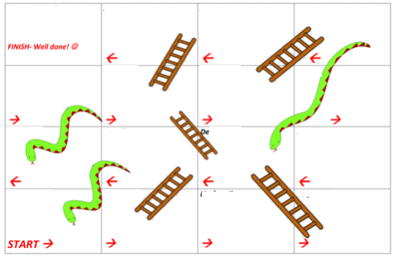

***Question 2:***

Draw a FA for the following languages

* Language of Strings that are valid email address of Fast university student
* Languages that are valid identifier of Python language

***Question 3***

For languages L1 to L10 over alphabets {a, b} do the following

1. Enumerate some elements
2. Draw a Deterministic Finite Automata

* L1: The language of all strings containing even number of a’s and each a is followed by at least one b.
* L2: The language that has even length and odd number of a’s.
* L3: The language of all strings in which every pair of adjacent b’s appear before any pair of adjacent a’s.
* L4: The language of all strings containing no more than one occurrence of the string aa. (the string aaa should be viewed as containing 2 occurrences of aa)
* L6: The language of all strings that begins and end with a triple letter( aaa or bbb)
* L7: The language of all strings containing at least two a’s and at most one b.
* L8: strings over {0,1} such that their decimal equivalent is multiple of 5
  + Eg: {0, 101, 10100, 00101, 10100101…..}
* L2: all strings over {a,b} that start with a and end with aba and do not have bbb as part of a string.
* L9: all the string x over {0,1}in which n0(x)%3=0 and n1(x)%3!=0
* L10: all the string x over {0,1}in which n0(x)%3=0 and n1(x)%3=0

***Question 4***

* Create and FA that accepts only λ
* Create and FA that accepts no string
* Create and FA that accepts all strings

***Question 5***

* Run FA of L8 of Question3: for following strings, and answer which ones are accepted and which are rejected
  + {000111, 101000, 10110100, 0000100000}
* Run FA of Question 2 for the following roll of dice, and specify state after every roll.
  + 1,1,6,3

***Question 6***

Simulator of Finite Automata

Simulator of FA is a program that should take description a finite Automate M (Q, Σ, q0, A,δ) and a String X as an input.

Simulator should then run string X on M.

Output of Simulator should be “1” if M accepts X. Otherwise output should be ‘0’

In this problem you have to write a pseudo code for simulator of FA